**浙大SDCBCM @RO test**

1. **Layout 位置**

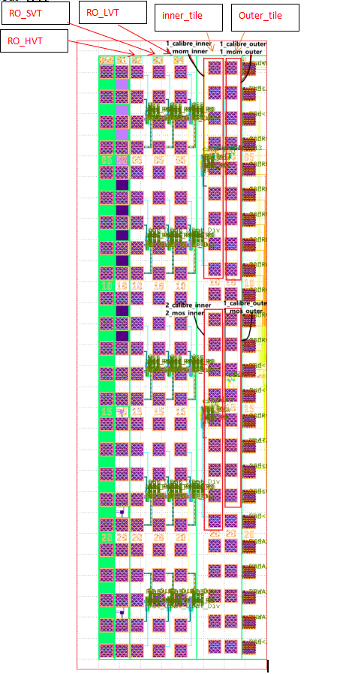

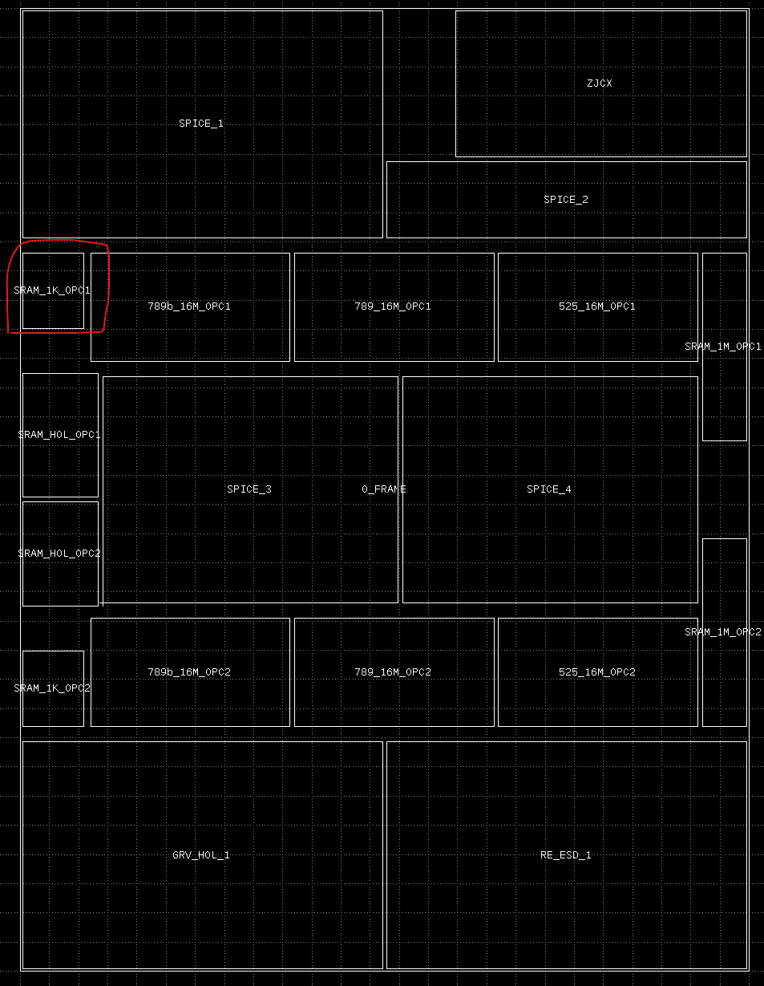

**原理图**

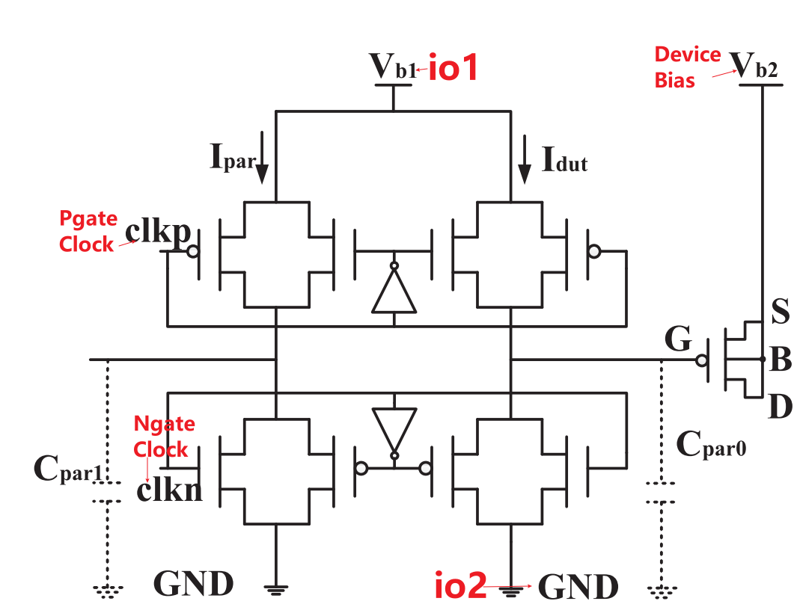

1. **CBCM 测试**
2. **CBCM（outer Injected Clock）**
3. **Cbcm pad 分布：**

|  |  |  |  |  |  |  |  |  |
| --- | --- | --- | --- | --- | --- | --- | --- | --- |
| Device | Tile | io1 | io2 | Pgate Clock | Ngate Clock | Device Bias | VDD | VSS |
| 1_calibre_outer | Outer_tile | 1 | 9 | 2 | 7 | NA | 4 | 5 |
| 1_mom_outer | Outer_tile | 3 | 6 | 2 | 7 | 8 | 4 | 5 |
|  |  |  |  |  |  |  |  |  |
| 2_calibre_outer | Outer_tile | 10 | 18 | 11 | 16 | NA | 13 | 14 |
| 2_mos_outer | Outer_tile | 12 | 15 | 11 | 16 | 17 | 13 | 14 |

1. **功能说明：**

|  |  |  |
| --- | --- | --- |
| NO. | item | Function |
| 1 | **io1** | sensor,扫sweep V,sense不同电压下充电电流 |
| 2 | **io2** | 连接GND，放电电流 |
| 3 | **Pgate Clock** | 提供脉冲信号 clkp |
| 4 | **Ngate Clock** | 提供脉冲信号 clkn,与clkp non-overlapping clock |
| 5 | **Device Bias** | 提供device电压（若有） |
| 6 | **VDD** | 接dc 1.2v |
| 7 | **VSS** | 接GND |

1. **测试信号说明：**

**Step1**

**io1：**扫dc电压 sweep from 0 to 1.2v，step=0.02v，共61个点

**io2：**连接GND

**Pgate Clock:** 加方波信号，低电压v1=0v，高电压v2=1.2v，delay td=0s,上升沿tr=2e-8s和下降沿tf=2e-8s，波宽pw=5e-7s，周期per=1.04e-6s

**Ngate Clock:** 加方波信号，低电压v1=0v，高电压v2=1.2v，delay td=1.5e-7s,上升沿tr=2e-8s和下降沿tf=2e-8s，波宽pw=2e-7s，周期per=1.04e-6s

Pgate Clock和Ngate Clock信号如table：

|  |  |  |  |  |  |  |  |
| --- | --- | --- | --- | --- | --- | --- | --- |
|  | v1 | v2 | td | tr | tf | pw | per |
| **Pgate Clock** | 0v | 1.2v | 0s | 2e-8s | 2e-8s | 5e-7s | 1.04e-6s |
| **Ngate Clock** | 0v | 1.2v | 1.5e-7s | 2e-8s | 2e-8s | 2e-7s | 1.04e-6s |

Pgate Clock和Ngate Clock波形示意图如下：

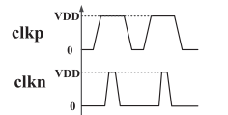

**Device Bias:** 加dc电压 1.18v(calibre不加信号)

**VDD:** 加dc电压1.2v

**VSS：**接GND

Tran 0 到 200us

测试**io1**每个电压下的电流 (取50us到150us的平均电流）

测试raw data需输出

**Step2** (calibre没有step2)

**Device Bias:**修改dc电压 1.22v

其他条件保持不变

Tran 0 到 200us

输出**io1**每个电压下的电流 (取50us到150us的平均电流）

测试raw data需输出

1. **CBCM（Inner Generated Clock）**
2. **Cbcm pad 分布：**

|  |  |  |  |  |  |  |  |  |
| --- | --- | --- | --- | --- | --- | --- | --- | --- |
| Device | Tile | io1 | io2 | RO_En | RO_Out_check | Device Bias | VDD | VSS |
| 1_calibre_inner | inner_tile | 2 | 8 | 1 | 9 | NA | 4 | 5 |
| 1_mom_inner | inner_tile | 3 | 6 | 1 | 9 | 7 | 4 | 5 |
|  |  |  |  |  |  |  |  |  |
| 2_calibre_inner | inner_tile | 12 | 18 | 11 | 19 | NA | 14 | 15 |
| 2_mos_inner | inner_tile | 13 | 16 | 11 | 19 | 17 | 14 | 15 |

1. **功能说明：**

|  |  |  |
| --- | --- | --- |
| NO. | item | Function |
| 1 | **io1** | sensor,扫sweep V,sense不同电压下充电电流 |
| 2 | **io2** | 连接GND，放电电流 |
| 3 | **RO_En** | RO的输入 |
| 4 | **RO_Out_check** | RO降频输出,后期反推clock信号的Freq |
| 5 | **Device Bias** | 提供device电压（若有） |
| 6 | **VDD** | 接dc 1.2v |
| 7 | **VSS** | 接GND |

1. **测试信号说明：**

**Step1**

**io1：**扫dc电压 sweep from 0 to 1.2v，step=0.02v，共61个点

**io2：**连接GND

**RO_En：**输入dc=1.2v

**RO_Out_check：** 输出波形图

**Device Bias:** 加dc电压 1.18v(calibre不加信号)

**VDD:** 加dc电压1.2v

**VSS：**接GND

Tran 0 到 200us

输出**io1**每个电压下的电流 (取50us到150us的平均电流）

输出**RO_Out_check** 波形图

测试raw data需输出

**Step2** (calibre没有step2)

**Device Bias:**修改dc电压 1.22v

其他条件保持不变

Tran 0 到 200us

输出**io1**每个电压下的电流 (取50us到150us的平均电流）

测试raw data需输出

1. **其他信息**
2. 温度：25 C
3. TestPlan: 见附件